11. Dezember

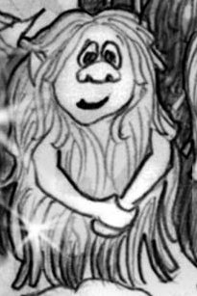 | Wuselsteckbrief (S.99)  Name : _____________________________________________________  Größe : _____________________________________________________  Alter : _____________________________________________________  Das habe ich über Wusel erfahren :  _______________________________________________  _______________________________________________  _______________________________________________  _______________________________________________  _______________________________________________  _______________________________________________  _______________________________________________  _______________________________________________

